Design

**Enemy design**

The enemies will be split into melee and ranged. The enemies will use the in-built Unity Navmesh to determine where in the map will be valid to step. The player models will be simple capsules and float toward the enemy.

The melee enemies will walk towards the player and attack if the player is in range. They will disappear if the health of the unit reaches 0. The ranged minions are divided into Bowmen and Mages.

Bowmen will retreat from the player and try to fire arrows to the player location. If they collide with the player, they will lose health. If it hits the terrain, the arrow will disappear after a time. Ammo will decrement with every shot fired. The bowman will try to retreat while they have ammo. If they run out of the ammo, they will change weapon to a knife and resume default melee pathing.

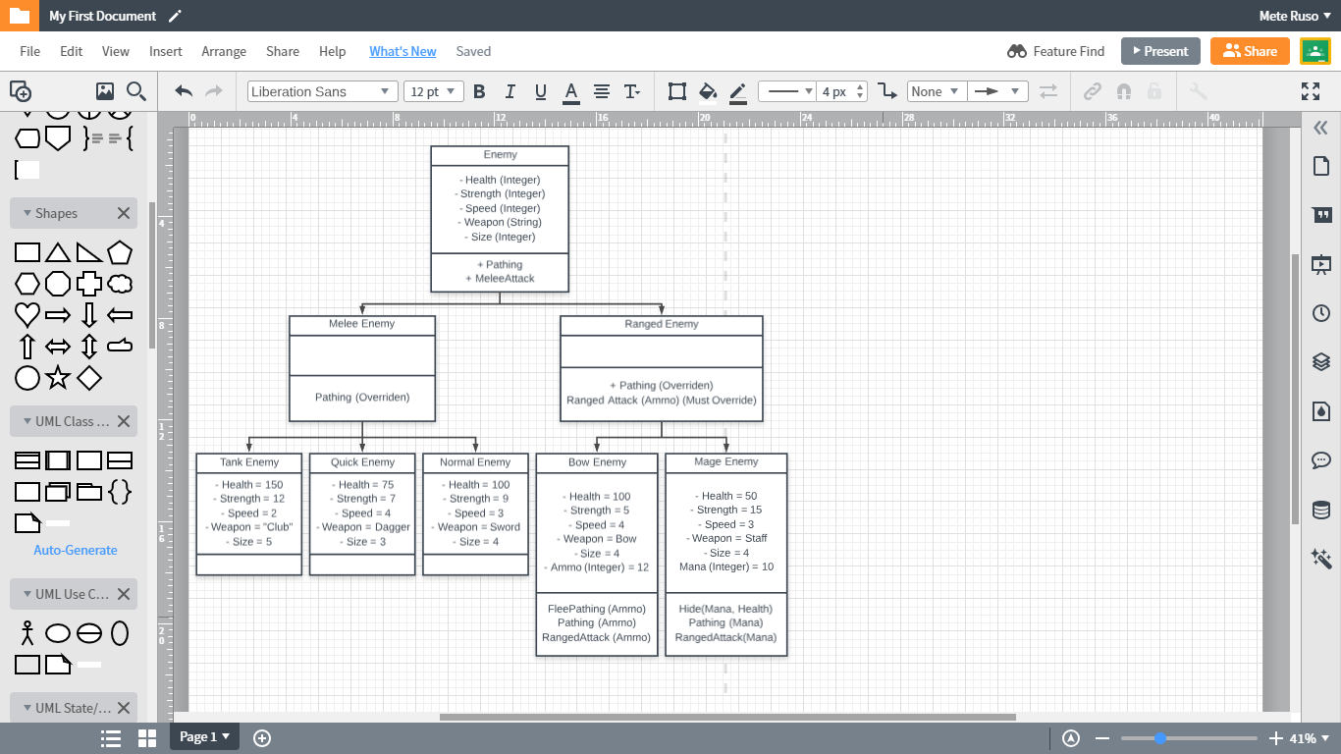Mages have the resource of Mana that also decrements with every shot fired. However this resource regenerates. If the mage runs out of Mana, they will flee a set distance away from the player. After a set amount of time, the Mana regenerates back to full and they resume throwing projectiles.

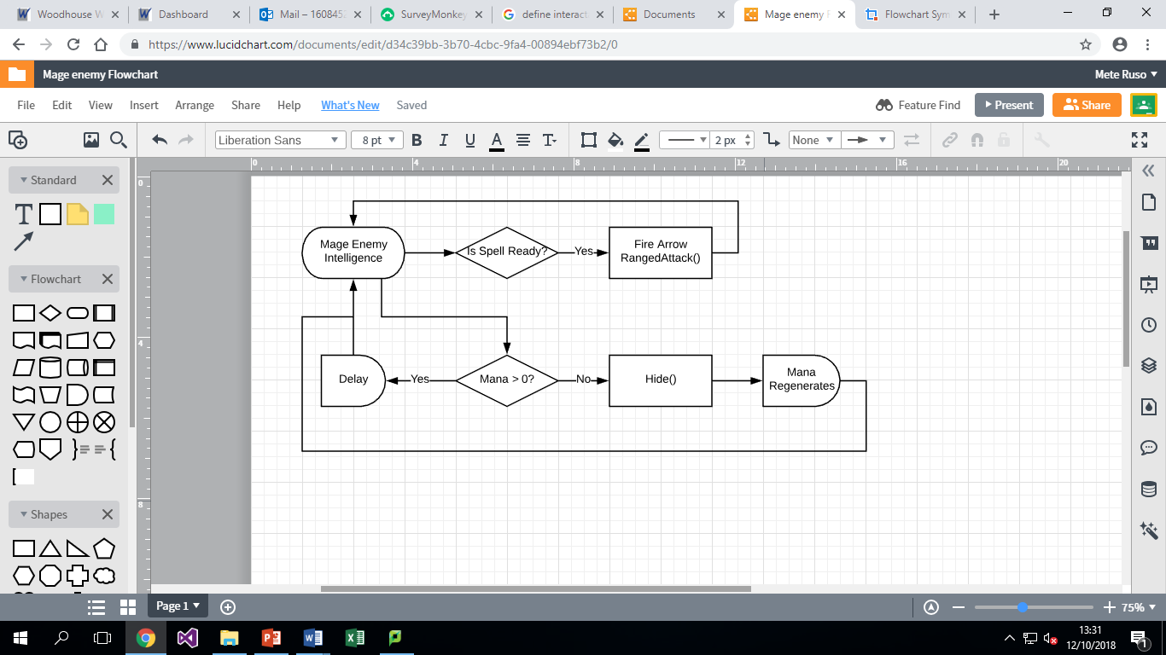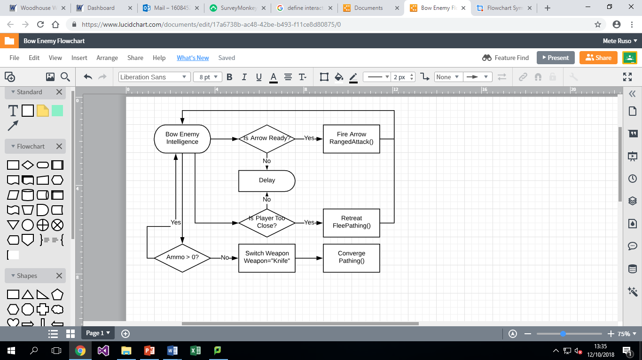

**Crosshair Algorithm**

There is a crosshair in the middle of the screen to let the player see what is in the precise centre of their screen. The sprite was scaled to 5% of the screen size then the size of the sprite was recorded.

Since the drawing of the crosshair started from the top left corner I had to run an algorithm:

xCoord = (ScreenWidth/2) – (SpriteSize/2)

yCoord = (ScreenHeight/2) + (SpriteSize/2)

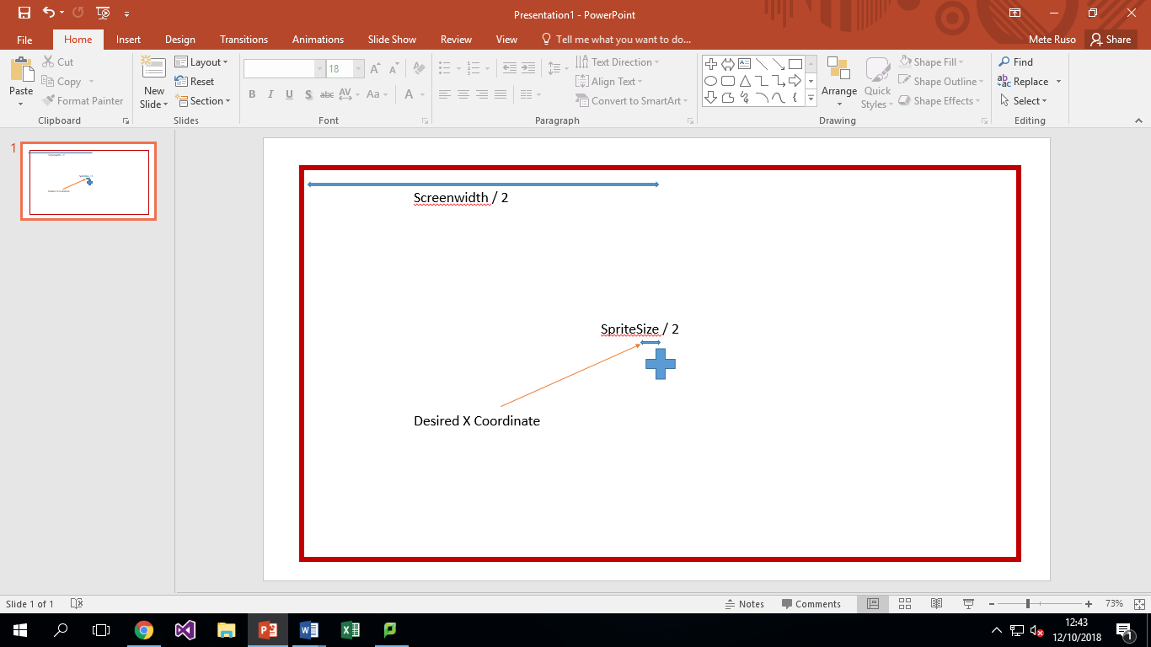

A ray cast of 4 units’ length is fired from the Player camera. This can hit the collider of an object. From the collider data we can find the name of the object and afterwards, the tags. If the raycast hits an item with a tag of an interactable item, the sprite will change from a cross shape to the object you can interact with i.e. Door, NPC, Chest, and Item.

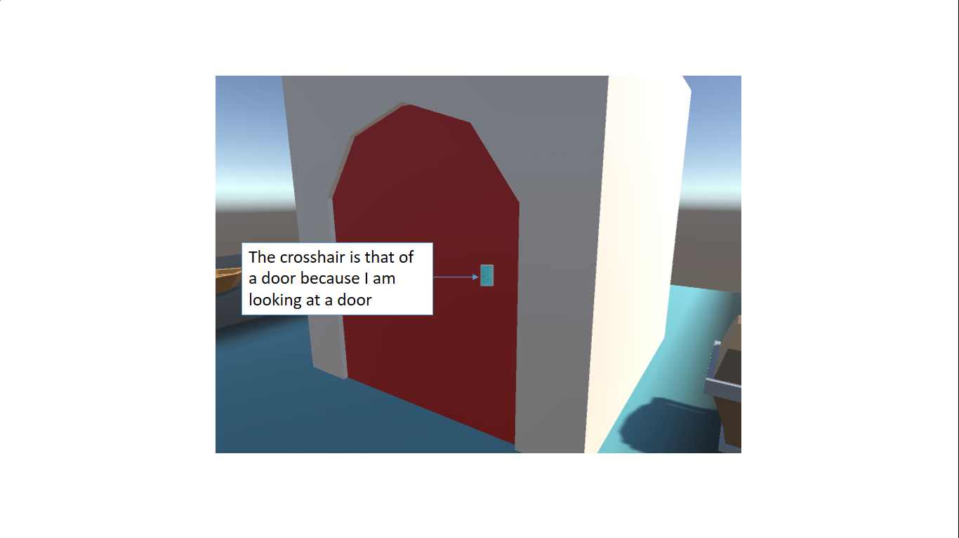

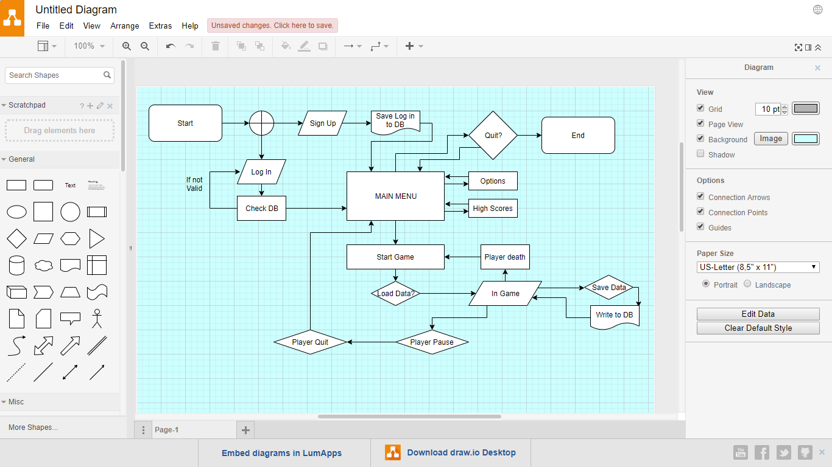

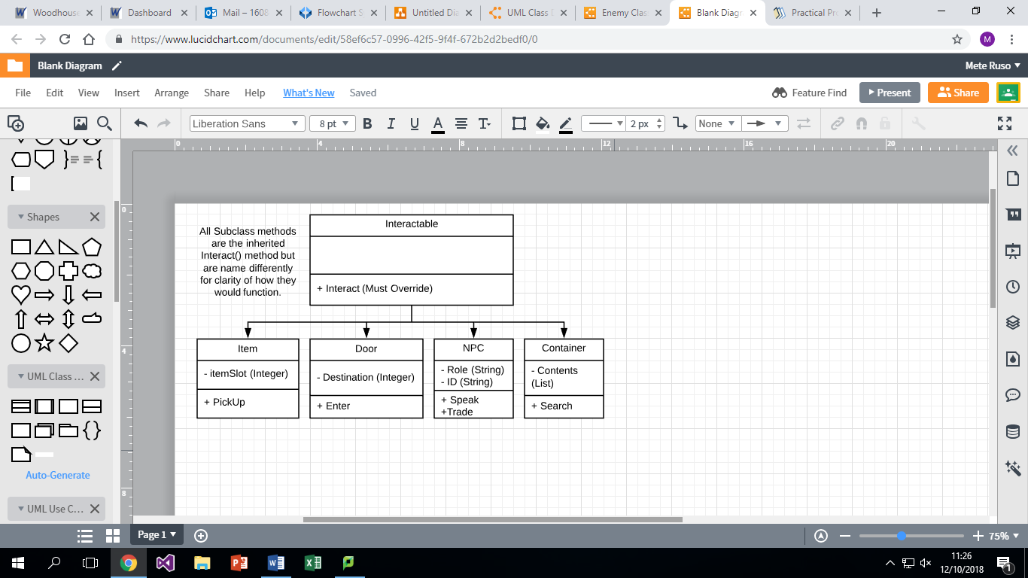

Crosshair Code